AKhan_Pr12 Documentation

Screenshots:

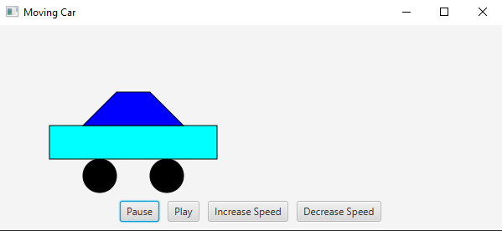

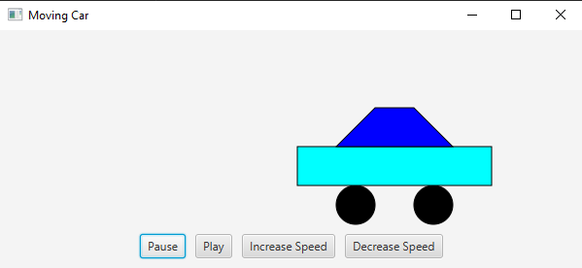

Test Cases:

|  |  |  |  |
| --- | --- | --- | --- |
| Case | Input | Output | Pass? |
| Is car drawn correct? | Button click | Works | Y |
| Does Car speed up and slow down | Button click | Works | Y |
| Does Car pause and play | Button click | Works | Y |

UML:

|  |
| --- |
| Class Project12 |
|  |
| +start(Stage primaryStage): void  +main()  -class CarPane  +CarPane()  +Reset()  +drawCar()  +moveCar() |

FlowChart: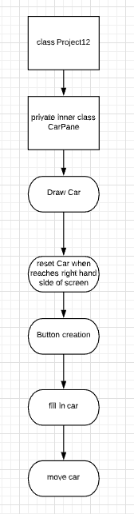

Lessons Learned:

I learned a lot about JavaFX and its applications. I never knew any of this was possible on a programming language built in. It was a lot of troubleshooting and different types of material to learn from. I also learned more about my IDE and configuration settings in order to make JavaFX work.

|  |  |  |  |
| --- | --- | --- | --- |
| **#** |  | **Y/N** | **Comments** |
|  | **Source java files** | **Y** |  |
|  | **Compressed files:** | **Y** |  |
|  | FirstInitialLastName_Project12_Moss.zip |  |  |
|  | FirstInitialLastName_Project12_doc.zip |  |  |
|  | **Program compiles** | **Y** |  |
|  | **Program runs** | **Y** |  |
|  | **Checklist is completed and included in the Documentation** | **Y** |  |
|  | **Documentation file:** |  |  |
|  | **Screenshots based on Test Plan** | **Y** |  |
|  | **UML Diagram** | **Y** |  |
|  | **Algorithms/Pseudocode** | **Y** |  |
|  | **Flowchart** | **Y** |  |
|  | **Lessons Learned** | **Y** |  |